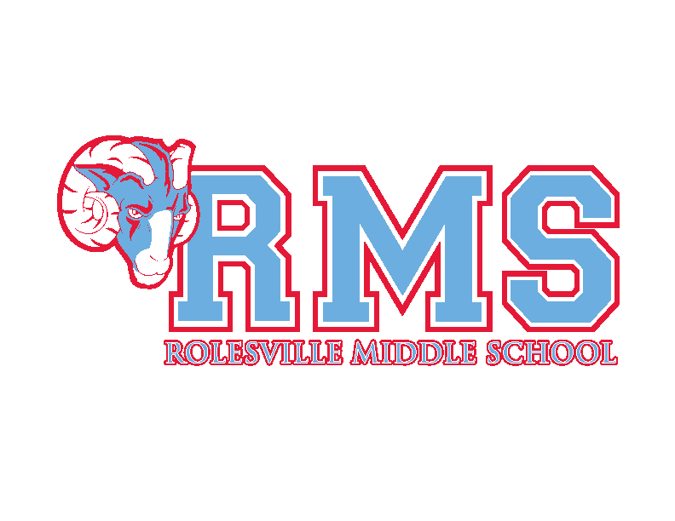
Rolesville Middle School Healthful Living Procedures

The procedures below are expected to be followed for the safety of all students in Healthful Living. Please have your parents read and fill out the back of this form and return it to your Healthful Living teacher.
Locker Room
- Students are expected to be on time. Students have four minutes to dress in/ out for class.
- Students should change into PE uniforms promptly and report to assigned area in the gym.
- No horseplay in the locker room.
- Students are expected to secure their belongings and leave other students’ property alone.
- Locks and belongings need to be removed from the locker room each day. No belongings are allowed to stay in the locker room overnight.
- All valuables should be left at home or in the hall locker (this includes IPODs, cameras, cell phones, wallets, and purses). Absolutely no electronics they will be taken and parents will have to pick up from the main office.

PE/Fitness Uniforms
- Students are required to wear the RMS PE uniform everyday for Physical Education - this includes shirt, shorts, socks, and proper tennis shoes. If a student does not have their PE uniform, he/she is still expected to participate in that day’s lesson. In Fitness and PE, you will not be allowed to participate on any equipment without proper footwear. Inappropriate attire is unacceptable.
  - RMS t-shirt/shorts from PTA or other sport team will be accepted as dressing out. This does not include actual team uniforms.
- The uniform should not be worn during any other part of the school day.
- Essential costs: Shirts: $6.00, Shorts: Youth, Ladies, and Men’s Regular Length $10.00 Men’s Adult Size Short extra length $11.00, and Locks: $5.00.

Behavior
- Good sportsmanship and self-control are expected behaviors. Profanity will not be tolerated.
- PE equipment should not be used unless instructed by a teacher. PE equipment should always be used properly and not in a way that could cause damage or harm to other participants.
- Gum, food, drinks, perfumes, lotions, and/or any type of AEROSOL prohibited in the gym and locker room area. This means NO lotions, perfumes, aerosols, gum, or food in the gym.

Grading
- Physical Education: Students will be graded as follows: Participation (Athletic/Social Etiquette & Sportsmanship)-10%, Instant Activity-5%, PE Uniform-5%, Fitness/Skills Assessments (Includes Pacer and Fitness Tests)-13%
- Health Education: Students will be graded on classwork and participation 14%, Quizzes/Tests/Projects: 20%.
- Fitness: Students will be graded on Fitness/Skills Assessments (Includes Walk/Run and other Fitness Tests)-13%, PE Uniform 5%, Participation 10%, and
Instant Activity 5%
No Homework – Students are expected to study for all assessments.

Injuries
- Please report any injuries immediately to your PE teacher or any PE staff member
- Only students with a note from a Doctor are excused from class. You must provide a doctor note when the student is released from injury restrictions. A one day parent note will be accepted, but must be followed on the second day by a doctor’s note. Only a doctor’s note excuses a student from class activities.

If you have any questions or concerns, please call or e-mail the Healthful Living Staff.

ROLESVILLE MIDDLE SCHOOL
HEALTH and PHYSICAL EDUCATION DEPARTMENT
STUDENT MEDICAL INFORMATION SHEET

Student Name:______________________________Date of birth:_______Age_____

Address_______________________________________________________________

City______________________________________Zip Code_____________________

Parent/Guardian________________________________________________________

Phone(H)_________________(W)_________________Email____________________

Parent/Guardian

Please answer the following questions concerning your child’s health.

- Does your child have any physical limitations that would prevent him/her from active participation in physical education?

Yes______________ No______________

- Has a medical doctor advised limited physical activity?

Yes_____________ No_______________

- Please list any physical limitations your child may have. Please be specific.

I have read the objectives and procedures of the Health and Physical Education Department.

Parent/Guardian Signature___________________________________________

Student Signature__________________________________________________

Date_____________________________________________________________

